**Lab Assignment-3**

**Android Application using Images and Location Servicing.**

Application has a SignUp page in which user has the facility to upload image either from camera or gallery.

After signing Up, User's location is populated on the screen.

**SCREENS:** Prompting User to choose between camera or gallery.

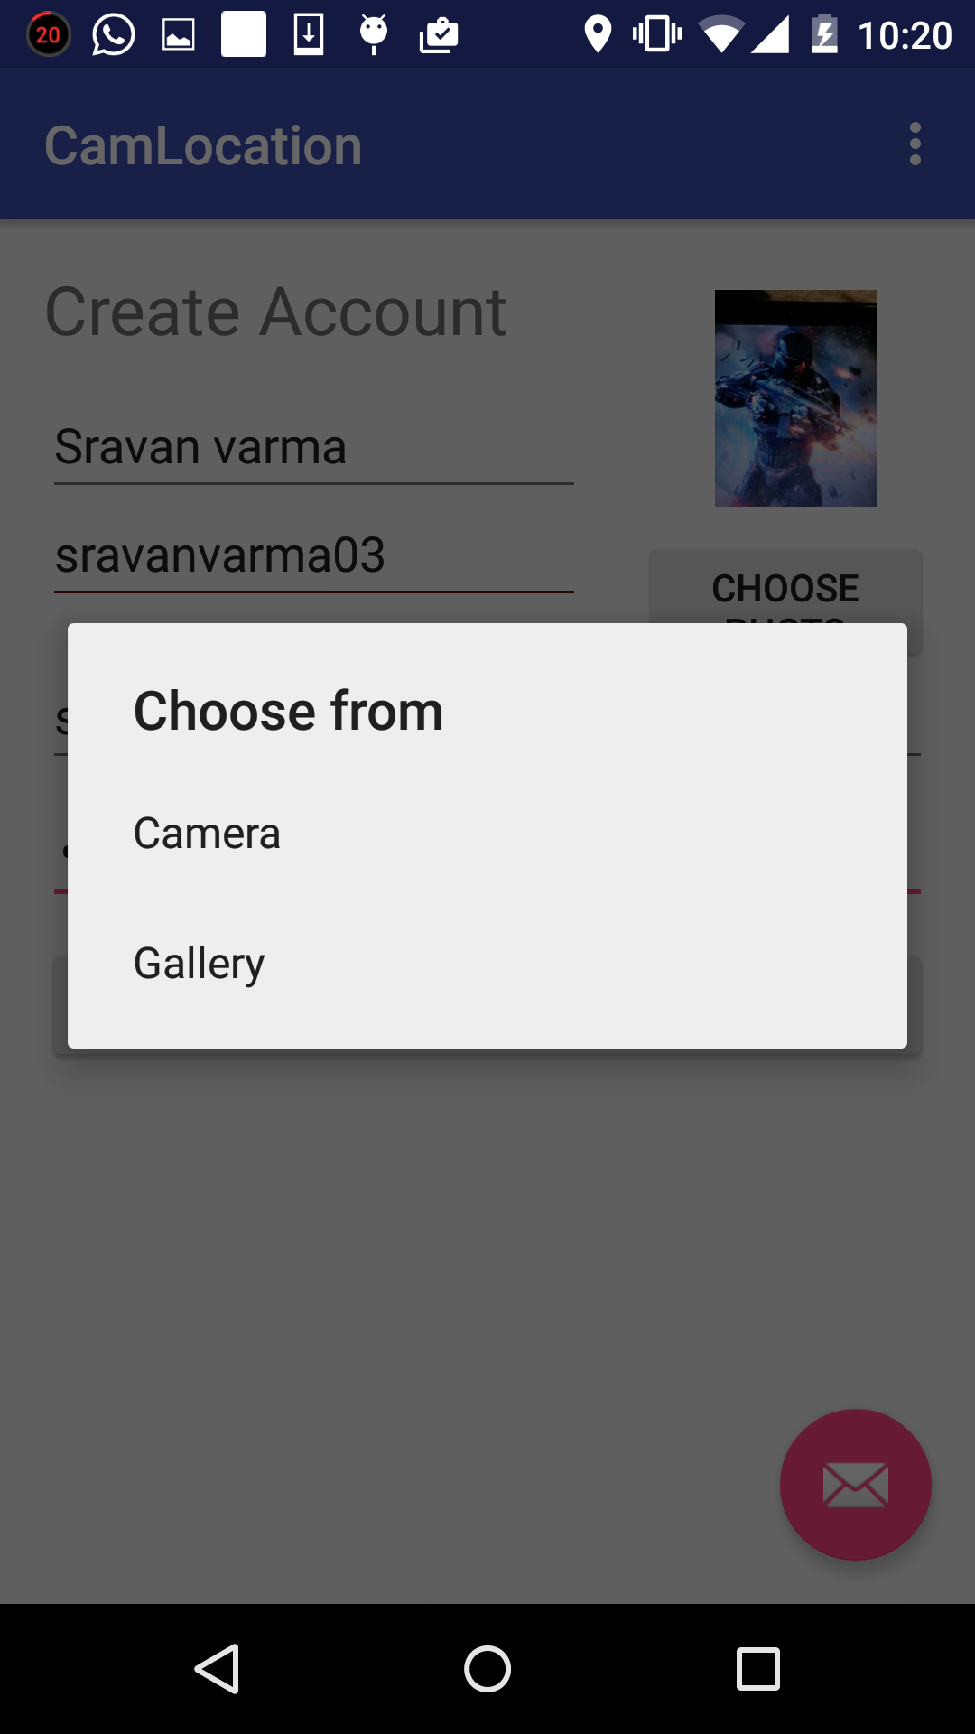

Give all the details 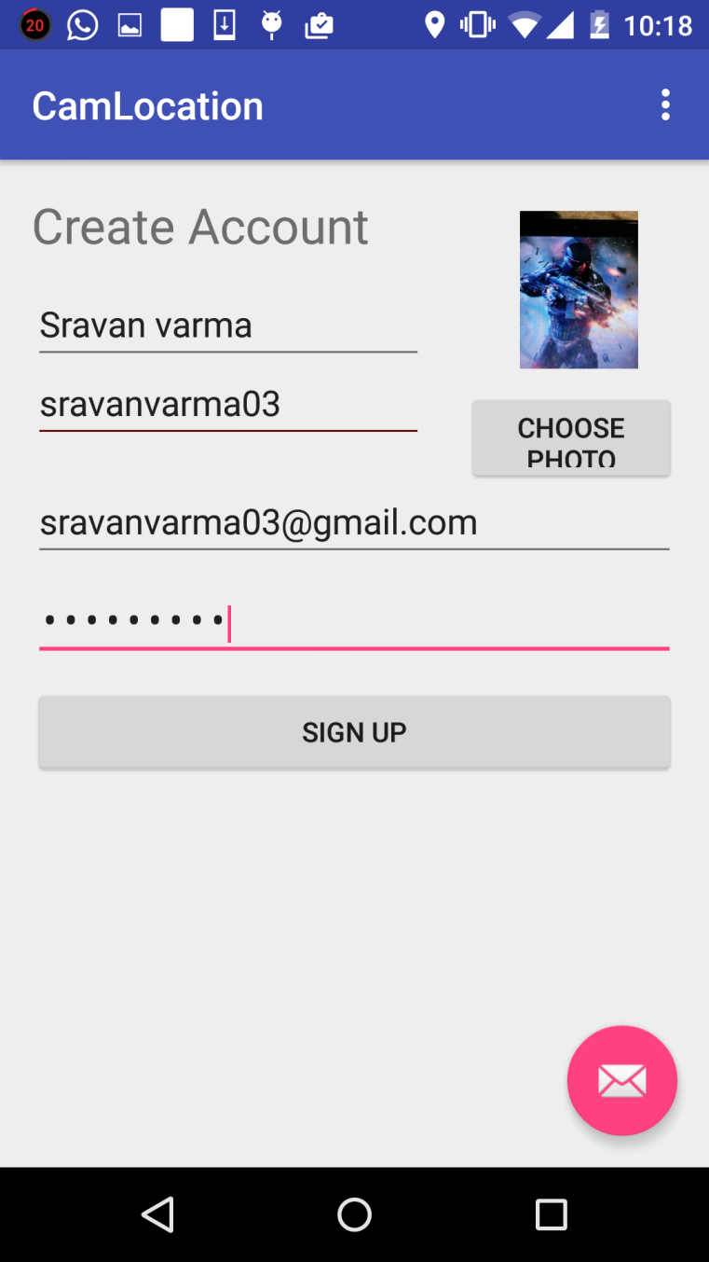

Location is populated on the screen with the same image as their Display picture.

